1. Title of the project/Assignment

MOBO(Movie Ticket Booking)

1. Introduction
   1. The goal of this document is to give brief description of Movie Ticket Booking Web Application called MOBO.
   2. This project will mainly let users to check movie review, rating and allow to book ticket.
2. **Project Functions**

Whole function will performed in this order.

* 1. **Sprint 1**

1. **General Requirements Details:**

Just a device with web browser and active internet connection.

1. **Top level requirements:**

The system will have 2 types of users.

* + - Admin
    - User

**Admin:**

1. Admin is the only person who has authority to add, edit and delete movie details like title, description, language, movie type, images, trailer video.
2. Admin is the only person who has authority to add, edit and delete theatre details i.e. screens, location, ratings.

**User:**

1. User first set location in which city, state he wants to watch movie.
2. User can select movie of his choice.
3. User can check movie details like description, language, trailer etc.

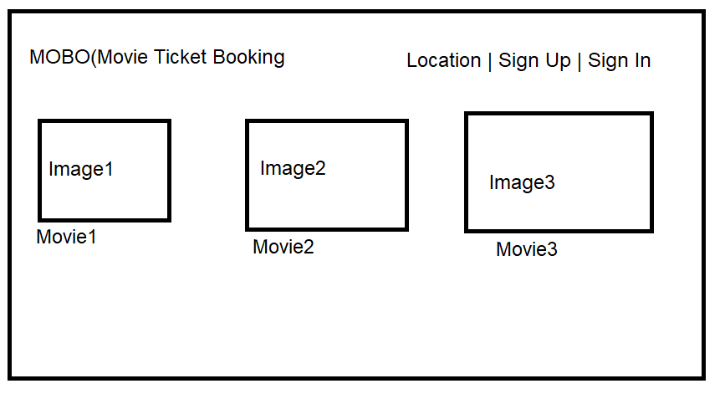

Figure 1: Home Page design

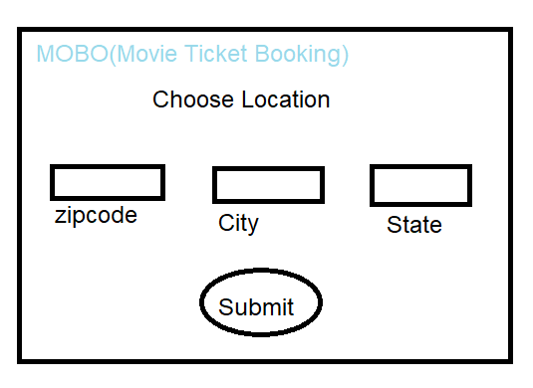

Figure 2: Choose location Page design

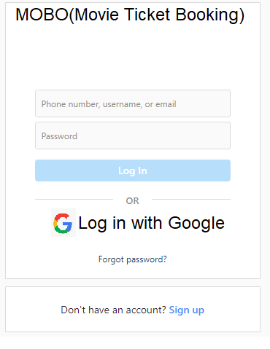

Figure 3: Login Page design

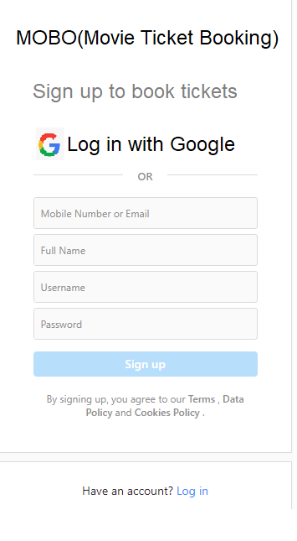

Figure 4: Sign up Page design

* 1. **Sprint 2**

**User:**

1. User once choose movie he can select shows at a particular theatre and book the tickets.
2. User will be able to select multiple seats according to their choice.
3. Tickets will be booked in FIFO manner.
4. User can do comments on movie as user reviews.